

Neat Sango

  rd’ dub Simulator time: 00:00:05 Code



Send To

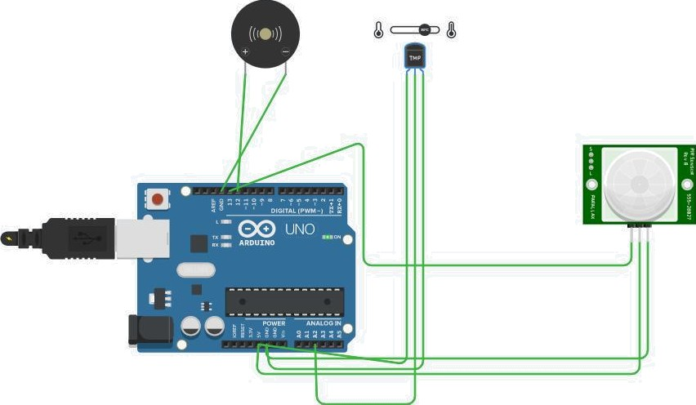 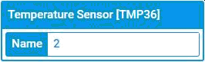

W Simulator time: 00:00:10 Code

III



Send To

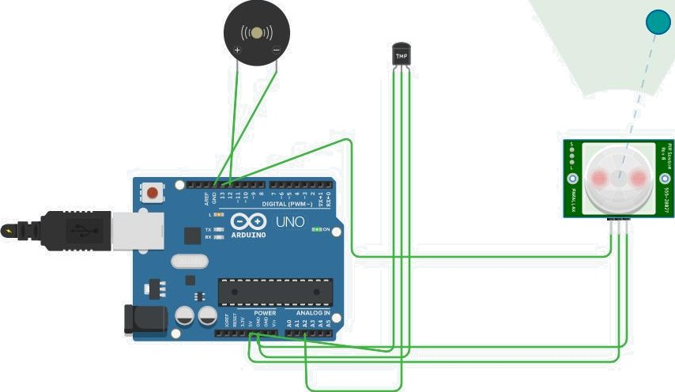 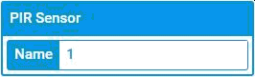

  Simulator time: 00:00:41.040





? void setup()

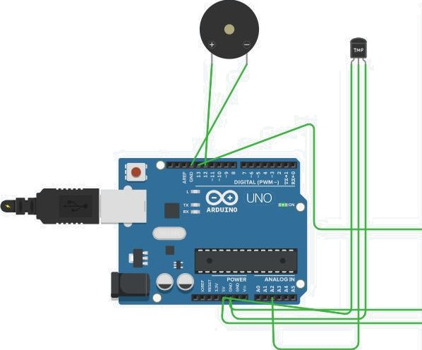Serial.begin(9650); ( pioMode(13,INPDT); o pioMode(12„OUTPUT};

# 2. void loop()

10 double dâta-analogRead{A2);

12 double .n-data/l0’24; lz dorible volt=S 5;

# i: double off=yolt-0..5;

14 dorible tezsperature=off*l5Q; lo iot motioo-digitalRead{l3); i% for]int fre —4;freq<-5;freq++}

Send To

# I ' 1 (Arduino Uno R3) •

if{tempe’raturev=60)

|  |  |  |  |
| --- | --- | --- | --- |
| 20 |  | Serial.priotln(’Temperature is | above) 60"); |
| 2? |  | tooe(l2,freq); |  |
| 22 |  | delay{l00); |  |
| 2 |  |  |  |
| 24. |  | e’lse |  |
| 2? |  |  |  |
| 2% |  | Serial.priotln(’Temperature is | below 60"); |
| 2' |  | ooTone(12); |  |
| 22. |  |  |  |
| 2.° | )’ |  |  |

for(iñt freq=2,freq<=3;freq*s)

if{motion 1}

# Serial Monitor •

’Untitled - Notepad 

Fiie Ed.t View @

v oi d set up ( )

Serial . begin ( 966B ) ; pinfiode ( 13, INPUT ) ; pinKode ( 12 OUT PUT ) ;

void loop()

double data=ama1ogRead(32); double m=data/1B24;

double volt=m*5;| double off=vo1t-8.5;

double temperature=off*1B0; imt motiom=digita1Read(13); for(imt freq=4;freq‹=5;freq++)

if(temperature›=68)

Serial. primtlm("Temperature is above 68"); tome(12,freq);

delay(2BB);

else

Serial.primtlm("Temperature is below 68"); moTore(12);

-F-or ( i nt -fl-r e q= 2 ; -Fr e q<= 3 ; -Fr e q++ )

if(motiom==1)

Serial.println("Notion Detected "); tone(12,freq);

delay(280);

el s e

Serial.primtlm(" No %otiom"); moTome(12);

di° 